City of Monroe, NC - Commercial Contract for Utility Services

|  |  |  |  |
| --- | --- | --- | --- |
| Today’s Date: | Requested Date of Service: | | |
| Service address: | | | |
| Own or Rent/Lease: | | | |
| Applicant Information | | | |
| Name of Business: | | | |
| Mailing address: | | | |
| City: | State: | ZIP Code: | |
| Email address: | | | |
| Business phone#: | Federal ID #: | | |
| Applicant’s name, title and contact phone#: | | | |
| Other Authorized Employees:  (name & title) | | | |
| Rules and Guidelines | | | |
| * A deposit may be required for new customers, you can provide a letter of credit from a prior utility provider that shows that you have established a good credit history for the most recent 12 months or you can give us permission to run a credit check on you using your Federal ID number. There is a $20.00 fee that will be charged to your first bill for the credit check. An application fee of $15.00 will be charged to your first bill for new customers and a $10.00 application fee will be charged to customers that have had service with us before. * All unpaid account balances on inactive accounts will be transferred to an active account and should be paid in full by the next cutoff date to avoid interruption in utility services at the active location. * A late fee of $5.00 or 1% of the delinquent balance will be added to your account after the due date, your account will be subject to disconnection 10 days after the due date. If your account is subject to disconnection or you have an item returned by a bank you may be billed a security deposit on a future bill. If your service(s) are disconnected due to non-payment a $30.00 fee will be added to your next utility bill. If your account is cutoff due to non-payment and your payment is made between 4:00 p.m. and 5:00 p.m. and you choose to have your service(s) restored that same business day, a $55.00 same day reconnect fee will be added to your next bill. * It is your responsibility to contact us to close this account when you no longer require utility service at this location. * If our Service Technician is unable to activate a water meter due to an open faucet or water line, a door hanger will be left and a $25.00 revisit fee will be charged to your account for each additional trip to the property. * Our Customer Service Policy and Fees Schedule are available on our website: www.monroenc.org select Departments, Finance & Customer Service. * Notice to Electric Customers: We are required by North Carolina Law (N.C.G.S. 160A-332(a) (6b) to notify you that you may be entitled to choose another electric supplier to provide you temporary or permanent service. Although this Notice is provided to all customers, customer choice only applies to certain new customers and NOT to existing customers. * Notice to Gas Customers: We are required by federal law (49 CFR Part 192.16) to notify you that you are responsible for the maintenance and locating of the customer owned fuel piping downstream of the meter (please see enclosed detail sheet).   By my signature below, I acknowledge receipt of these notices. | | | |
| Would you like for us to run a credit check on your Federal ID # at a cost of $20.00? Yes  No | | | |
| Signature of applicant: | | | Date: |
| Signature of co-applicant: | | | Date: |

**This information only applies to Natural Gas Service Applicants.**

C:\Users\dwhitesi\AppData\Local\Microsoft\Windows\Temporary Internet Files\Content.Outlook\W6DVW4XB\CoMonroe logo for Dawn.jpg

Energy Services Operations Center (704) 282-4600

Customer Service/Billing (704) 282-4511

**Notification – Customer Owned Piping on a Gas Service Facility**

It is our responsibility as a natural gas provider to notify you regarding your responsibility for customer owned fuel piping, which is the pipe downstream of the meter. You are responsible for the maintenance and locating of the customer piping. The City does not maintain that piping.

Customer owned facilities are those that extend from the outlet side of the City's meter to a dwelling, business, or other structure on the customer’s property. The City of Monroe's Natural Gas Department is responsible for the installation and maintenance of the natural gas pipeline up to the meter as outlined by the U.S. Department of Transportation - Pipeline Safety Regulation 192.16.

(See the illustration)

If the customer fails to maintain their buried piping and other gas facilities properly, the following may occur:

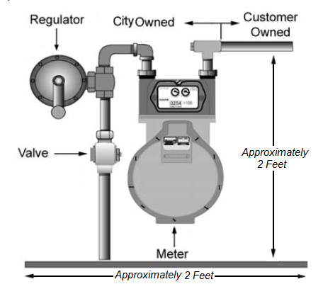

Gas Flow

1. A metal gas line may be susceptible to hazards, such as corrosion and leakage;
2. A plastic gas line with a broken or no tracer wire may be susceptible to damage by an excavator if it’s location is not marked.
3. Certain types of plastic are prone to cracking and other material deficiencies.

Buried gas piping should be:

1. Periodically inspected for leaks;
2. Periodically inspected for corrosion (if the piping is metallic); and
3. Repaired if any unsafe condition is discovered.

Prior to excavating near buried natural gas piping, its location should be marked in advance, and the excavation should be done by hand. Customers may contact North Carolina 811 by dialing 811 in order to arrange for the City of Monroe to locate its gas facilities on their property. Customers may maintain, locate, inspect, or repair their facilities themselves or contact a local plumbing contractor(s) or heating contractor(s) for assistance.

Please feel free to contact the City’s Energy Services Department at (704) 282-4600 with any questions regarding this requirement.

For questions regarding Natural Gas Safety, please refer to our website: [http://energy.monroenc.org/147](http://www.monroenc.org/services.php?cat=125)